Use of Social Networking Analyses of Twitter Interactions to Understand the Field of Educational Technology

Basdogan Merve ^{a,*}, Curtis J. Bonkª, Ozdogan Zulfukar ^{b}

ª Dept. of Instructional Systems Technology, School of Education, Indiana University, United States
^{b} Dept. of Inquiry Methodology, School of Education, Indiana University, United States

Abstract
This study attempts to understand interrelationships among five disciplines which are often used interchangeably, including Educational Technology, Educational Design, Instructional Design, Learning Design, and Instructional Systems. The purpose is to better understand their interaction in the job market using a systems thinking approach in which how they are "coded" as jobs in the social media and how they are defined in the directed post. Data were collected using a social network analysis tool, Ncapture, and imported to qualitative analysis software NVivo to conduct thematic analyses. For this study, 171 job postings in Twitter were captured by using NCapture as a Web-browser extension. Findings indicated that the relations between the targeted disciplines can be explained by Hall’s (1980) communication model. Results can serve as a guide for both employers and employees to make more accurate decisions in both hiring people and applying to educational technology positions.

Introduction
There is little doubt that learning environments have experienced dramatic changes during the past two decades (Brown & Adler, 2008; Peppler 2013; Scanlon, 2013; Sharples et al., 2014). In fact, there are dozens of ways that human learning is changing (Authors, 2016). For instance, learning is now more open, online, blended, mobile, collaborative, social, video-based, hands-on, ubiquitous, global, game-like, and massive. Such rapidly increasing and expanding capabilities of learning technology have had a profound impact on the teaching-learning situation (Hlynka & Jacobsen, 2009). The tendency to attempt to incorporate emerging technologies into education, across sectors from K-12 schools (Adams Becker, Freeman, Giesinger Hall, Cummins, & Yuhnke, 2016; Hartman, 2016) to higher education (Johnson et al., 2016) to corporate, military, and government training (Ravipati, 2016; Robbins, 2016), increases the significance and potential impact of the discipline of educational technology (e.g., Berrett, 2016; Chang, 2016; Fischer, Hilton, Robinson, & Wiley, 2015; Riter, 2016).
Educational technology is the study and practice of facilitating learning and enhancing performance by generating, selecting, and controlling appropriate technological processes and resources (Januszewski & Molenda, 2008). However, as various learning technology continues to develop, the disciplinary boundaries between the professional fields become blurry (Gibbons, 1997; Hlynka & Jacobsen, 2009). Contrary to the traditional, institutionalized knowledge structures, knowledge is now generated by cooperation among disciplines (Klein, 1990). For example, the tasks of the educational technologist are increasingly complex, evolving, and, with the rise of online and blended forms of learning (Allen & Seaman, 2013; Authors, 2006; Owston, 2017), are growing in importance (Berrett, 2016, Intentional Futures, 2016; Riter, 2016). As a result of this complexity and fast changing nature of the discipline, the field of educational technology suffers from a huge and growing identity crisis (Corbeil, & Corbeil, 2013).
In a similar vein, the field of the instructional design has also considered to have an interdisciplinary nature that is influenced by psychology, communication, and management fields (Ely 2008). According to Riter (2016), “Great instructional designers must become experts in a near-limitless set of overlapping solutions to produce tractable, informed decisions.” However, pedagogical challenges and rapid changes in learning technologies present marked challenges for instructional designers and others in this field to keep track of and then attempt to design and implement the necessary guidelines and training programs.
With the rapid increase in online and blended learning courses and programs (Allen, & Seaman, J. with Poulin and Straut, 2016; Stansbury, 2017), instructional design and related skills are increasingly sought after; especially in higher education settings (Berrett, 2016). Ritter (2016) mentioned that LinkedIn tripled its’ postings of open instructional designer positions alone from 2013 to 2016 to somewhere around 15,000. He further notes that CNN Money (2012) anticipates the field to grow by over 28 percent in just ten years from 217,700 total jobs in 2012 to nearly 280,000 by 2022. Given such trends, there will be a wide array of instructional designer jobs to fill in the coming years, let alone quality assurance personnel, program managers, testing and evaluation staff, and online learning directors and related administrators.
As the delivery of online courses has matured and the technologies to reach and engage students have become increasingly sophisticated, the set of skills required have evolved; in fact, the psychological and design considerations are particularly complex in blended learning environments (Owston, 2018). The vast amount of job openings advertised at the intersection of learning and technology (Kim, 2018) necessitates the need to gain a better understanding about the responsibilities for each type of job, and the qualifications expected for each. Better understanding of the requisite competencies and job duties is vital for both those engaged in the recruitment of educational and instructional technologists as well as those searching for positions.
There have been recent inroads in this area. For instance, as highlighted in the Intentional Futures (2016) report, funded by the Gates Foundation, instructional designers are diversely trained and qualified, and they are far from one-size-fits-all. They are called on to help with e-learning, blended learning, self-paced, and residential courses, including those that are highly informal, flipped, mobile-based, and, at times, highly massive as well as various combinations and derivatives of such delivery formats (Authors, 2015, 2016). According to the International Futures report, their responsibilities include to: (1) design, (2) manage, (3) train, and (4) support. This report also argues that instructional designers have become pivotal players in bridging the gaps between traditional instruction and emerging online learning, instructor-centered forms of instruction and that which is more learner-centered, and pedagogical needs for interactive and engaging forms of learning and the tools and applications that have emerged during the past decade. Still, this report notes that many questions remain about what instructional designers do and where they actually fit or are housed in higher education and other educational sectors.
Through a survey of over 850 people working in higher education institutions in instructional design, course design, or related fields, this comprehensive report offers an insightful and quite candid look at the experiences, ages, educational backgrounds, skills, tools, and even the personas needed to be successful as an instructional designer (Intentional Futures, 2016). The skills that were reported as useful varied from project management to strategic planning to research to data analysis to instructional design models to learning new and emerging technologies to graphic design to multimedia production to coding to publishing to teaching and much more. The report even offered a glimpse into the barriers to success, career paths, professional development opportunities, and typical days of an instructional designer.

While it is highly useful, the Intentional Futures (2016) report primarily focused on instructional designer job duties; it did not specifically explore learning experience designers, educational designers, instructional technologists, instructional systems designers, and other related training and development personnel. In addition, it was more practice-focused than research-based. Another problem was that this report relied on survey data for its findings which has various limitations including reliability issues related to self-report data. In contrast to that report , this study compares five disciplines including Educational Technology, Educational Design, Instructional Design, Learning Experience Design, and Instructional Systems which are often used interchangeably and can cause confusion. The purpose of this comparison is to explore the interconnectedness and interrelationships of the targeted fields to describe their scope in the job market using a systems thinking approach. By describing the responsibilities and informing the qualifications needed in these jobs, the researchers hoped that the resulting findings could be useful for both job applicants and employers.

In this paper, we use Twitter posts as data sources since social media aggregates a great variety of the perspectives. In other words, social media, as vehicles for communication, collaboration, networking, and interaction (Chen & Bryer, 2012; Veletsianos & Navarrete, 2012), is used to obtain an in-depth picture of the broader job postings at the intersection of learning and technology.

Theoretical Framework
Systems thinking is defined as the ability to think about a system as a whole, rather than only considering the individual parts (Aronson, 1998). System thinking could enhance our ability to recognize the system as the base for our communication. In other words, system thinking could be visible for us within the reifications of communication products. First of all, system approach typically expands and improves actor or stakeholder understanding of certain social systems by allowing them to perceive the overriding macro structure or big picture (Meadows, 2008).
Meadows (2008) identifies three essential components of the systems thinking: (1) elements, (2) interconnections, and (3) functions. Whereas elements refer to the characteristics of the individual parts, interconnections relate to the feedback mechanisms among the elements. Functions, on the other hand, are associated with the purpose of the system that is often the most critical determinant of the system’s behavior. Following Meadows's steps and some insights from Tang (2013), these discussions need to be articulated from the critical perspective of cultural and communication studies. The reasons for this need are based on the recent improvements and proliferations of instructional and learning technologies (Author, 2016) as well as the recent shift of learning and teaching philosophies, approaches, and specific strategies related to from highly teacher-centered toward more student-centered environments. Such technological advancements also alter the time, space, and potential audience in which learning and instruction occurs. Instructional technology personnel need to not only understand these shifts, but to find ways to take advantage of them.
Meadows's three essential components of system thinking are empirically and analytically discussed by using job ads about Educational Technology, Educational Design, Instructional Design, Learning Experience Design and Instructional System. The synthesis of Meadow's model and Stuart Hall's model still has some premises to explain the cultural circulation of job ads (announcement) regarding their "elements" (how they are produced (coded) in Hall's sense), their "interconnections" (circulation of meanings and meta of job ads) and their functions (how and why they are consumed). The research design is detailed in the methodology section.

Within this synthesis, the relevant literature on the definitions of each job defines the elements of the current study. The key elements and definitions of the five targeted disciplines are detailed in Table 1.

Table 1. Definitions of the targeted disciplines

Elements | Definition
Educational Technology | The study and ethical practice of facilitating learning and improving performance by creating, using, and managing, appropriate technological processes and resources (AECT, 2004).
Educational Design | Education is defined as planned and unplanned activities and resources that support learning regardless of whether the learning is intentional or unintentional (AECT, 2004). Educational design is a professional practice with its roots in the systems model of instructional design (Gagné & Briggs, 1974). It usually deals with the integration of appropriate learning theory into the learning materials and events being designed in order to ensure that learning is maximized.
Instructional Design | Instructional Design is that branch of knowledge concerned with research and theory about instructional strategies and the process for developing and implementing those strategies. It also can be considered as a process of planning instruction. Instructional design seeks to answer three questions: Where are we going, how will we get there, and how will we know when we arrive (Beattie, 1999)?
Learning Experience Design | This branch of knowledge is a process of facilitating the development of skills and expertise by providing learners with a systematic set of activities, content, feedback, and technology (Walsh, 2017).
Instructional Systems | The science and art of creating detailed specifications for the development, evaluation, and maintenance of situations which facilitate learning and performance (Richey, Klein, & Tracey, 2011).

In the typology of Stuart Hall, there is a continuous exchange/cycles between "encoder" and "decoder" position. According to Hall (1980), the cultural meta have their own positions to be exchanged by its user and producers. His model outlines six different variances between these positions. Encoding positions have three subcategories. These categories could be defined as the different interpretations of cultures to produce the cultural materials. In other words, the text during the writing process has to be culturally and linguistically meaningful for others. To make text meaningful for others, the cultural resources are used and reused by encoders. Hall (1980) defined the process as the reproduction of cultural existence. The second position is taken by users (i.e., the consumers). For example, any text, messages, signs and material have to be decoded into the life itself. Like the encoding position, decoding position has three different positions to be reached the text in a meaningful way. The modified table to explain his typology is presented in Table 3.

Table 3. The modified encoding/decoding typology for communication meta (instruments)
 |  | ENCODING POSITIONS
 |  | Dominant-hegemonic  encoding | Negotiated Encoding | Oppositional encoding
DECODING POSITIONS | Text-accepting  Position | Mutual  Acceptance | Acceptance vs. Negation | Acceptance vs. Opposition
 | Text-negotiation  Position | Domination vs. Negation | Mutual  Negotiation | Negation vs. Opposition
 | Text-oppositional  position | Domination vs. Opposition | Opposition vs. Negation | Mutual Opposition

Methods
The connections and interactions among the five targeted disciplines (i.e., Educational Technology, Educational Design, Instructional Design, Learning Experience Design, and Instructional Systems Technology) were examined using Social Network Analysis (SNA) (Wasserman, & Faust, 1994). As an analytical method of social networks, SNA consists of nodes (agents) and links (relationships). To make relationships among them visible, two different strategies were used. First, the researchers investigated the templates of each job announcement. Job announcement is taken as a mediated and already-given communication instrument for this strategy. The goal of the template analysis is the development of a coding list, to observe the categories among them, and schematize the interconnections among the codes.
Codes are the labels that are attached to phrases, expressions, words, and references from the data. Another analytical step is to make sense of the categories of codes. It is a logical act to organize the coded segments. The aim is to use a category based on the researcher intention to reduce the number of different codes into some groups. The theme is an inquiry act to see the major and higher categories. In this study, the template analysis means that the outlines of job ads were coded by looking at the titles and subtitles that are easily objectified by any reader. To check and reach an agreement about the labeling of the structural codes emerged from the template. Two of the researchers regularly discussed the codes and shared each other by using Nvivo. During the initial analyses and discussions, the categories were also articulated regarding the research questions. These interpretive acts like triangulations of sources and methods (Merriam, 2009, p.219) and prolonged engagement (Yin, 2011, p.79) are the part of the credibility in qualitative research defined in Lincoln and Guba (1985). The second strategy is based on the langauge-in-use to interpret the data. Various words were chosen by researcher to determine the way in which they are used. This kind of coding strategy helped us to read the data intertextually around these words.
Although the nodes are associated with individual actors within the network, the links depict relationships among individuals. SNA can identify how these relationships are established and then later evolve in a group of people such as an online learning community (Lee, 2016).
In this study, the analysis of job postings on Twitter was conducted to better understand the interactions and expected responsibilities for each discipline. This purpose led to the following two research questions:
1. What are the interrelationships among the targeted disciplines based on job descriptions?
2. What are the expected roles of professionals working in the targeted disciplines based on the Twitter job announcements and the content of the announced job?

Data Sources and Data Analysis

Narrative about the data preparation
The data was collected using a social network analysis tool, Ncapture. First, Twitter data was collected by using the following keywords: educational technology jobs, educational design jobs, instructional design jobs, learning experience design jobs, and instructional systems jobs. Job postings containing the keywords mentioned above were derived from both professional organization Twitter accounts and individual Twitter accounts. Next, these data were imported into NVivo (2016) for qualitative analyses. More specifically, the objective was to conduct a thematic analysis (Braun & Clarke, 2006) and attempt to answer the two key research questions noted earlier. The analysis was conducted by two researchers in order to ensure trustworthiness and triangulation of the data (Merriam, 1995).
The first semi quantitative analysis was conducted to determine the frequency of words, frequency of hashtags, mentions, and locations. While looking at the different interactions among the tweet and retweets, hashtags and mentions, and the number of nodes about the mentions, the locations and names helped the researchers to better grasp the possible relations and language usage in the tweets.

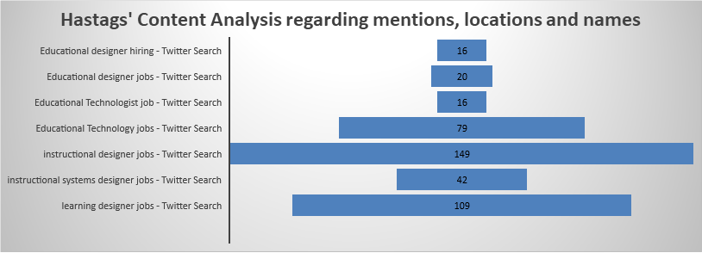

The dataset obtained from Twitter included the following: N=95 tweets for educational technology jobs, N=36 tweets educational design jobs, N=149 tweets for instructional design jobs, N=109 tweets for learning experience design jobs, and N=42 tweets for instructional systems jobs were collected. The results are presented in the next section.

Findings
Descriptive Template Analysis
The descriptive analysis of the job postings revealed that the number of nodes (codes) in each discipline are as follows: (1) Educational Technology = 38; (2) Educational Designer = 16; (3) Instructional Designer =24; (4) Instructional System Designer = 26; and (5) Learning Experience Designer = 27. Among these nodes; Responsibilities, Qualifications, Requirements, Experiences, Ability and Skills, and Preferences are the top five nodes having the highest number of references as noted in Table 3.

Table 3. Qualitatively coded nodes and the number of references
Node | The number of reference
Responsibilities | 37
Qualifications | 21
Requirements | 18
Experience | 13
Ability and Skills | 11
Preferences | 10

Figure 1 displays the number of node references by the field. The graph indicates that "General Responsibilities" is repeated more at Learning Experience Design posts compared to the other fields. Similarly, "Qualifications" are highlighted more in the Instructional Systems Designer jobs.
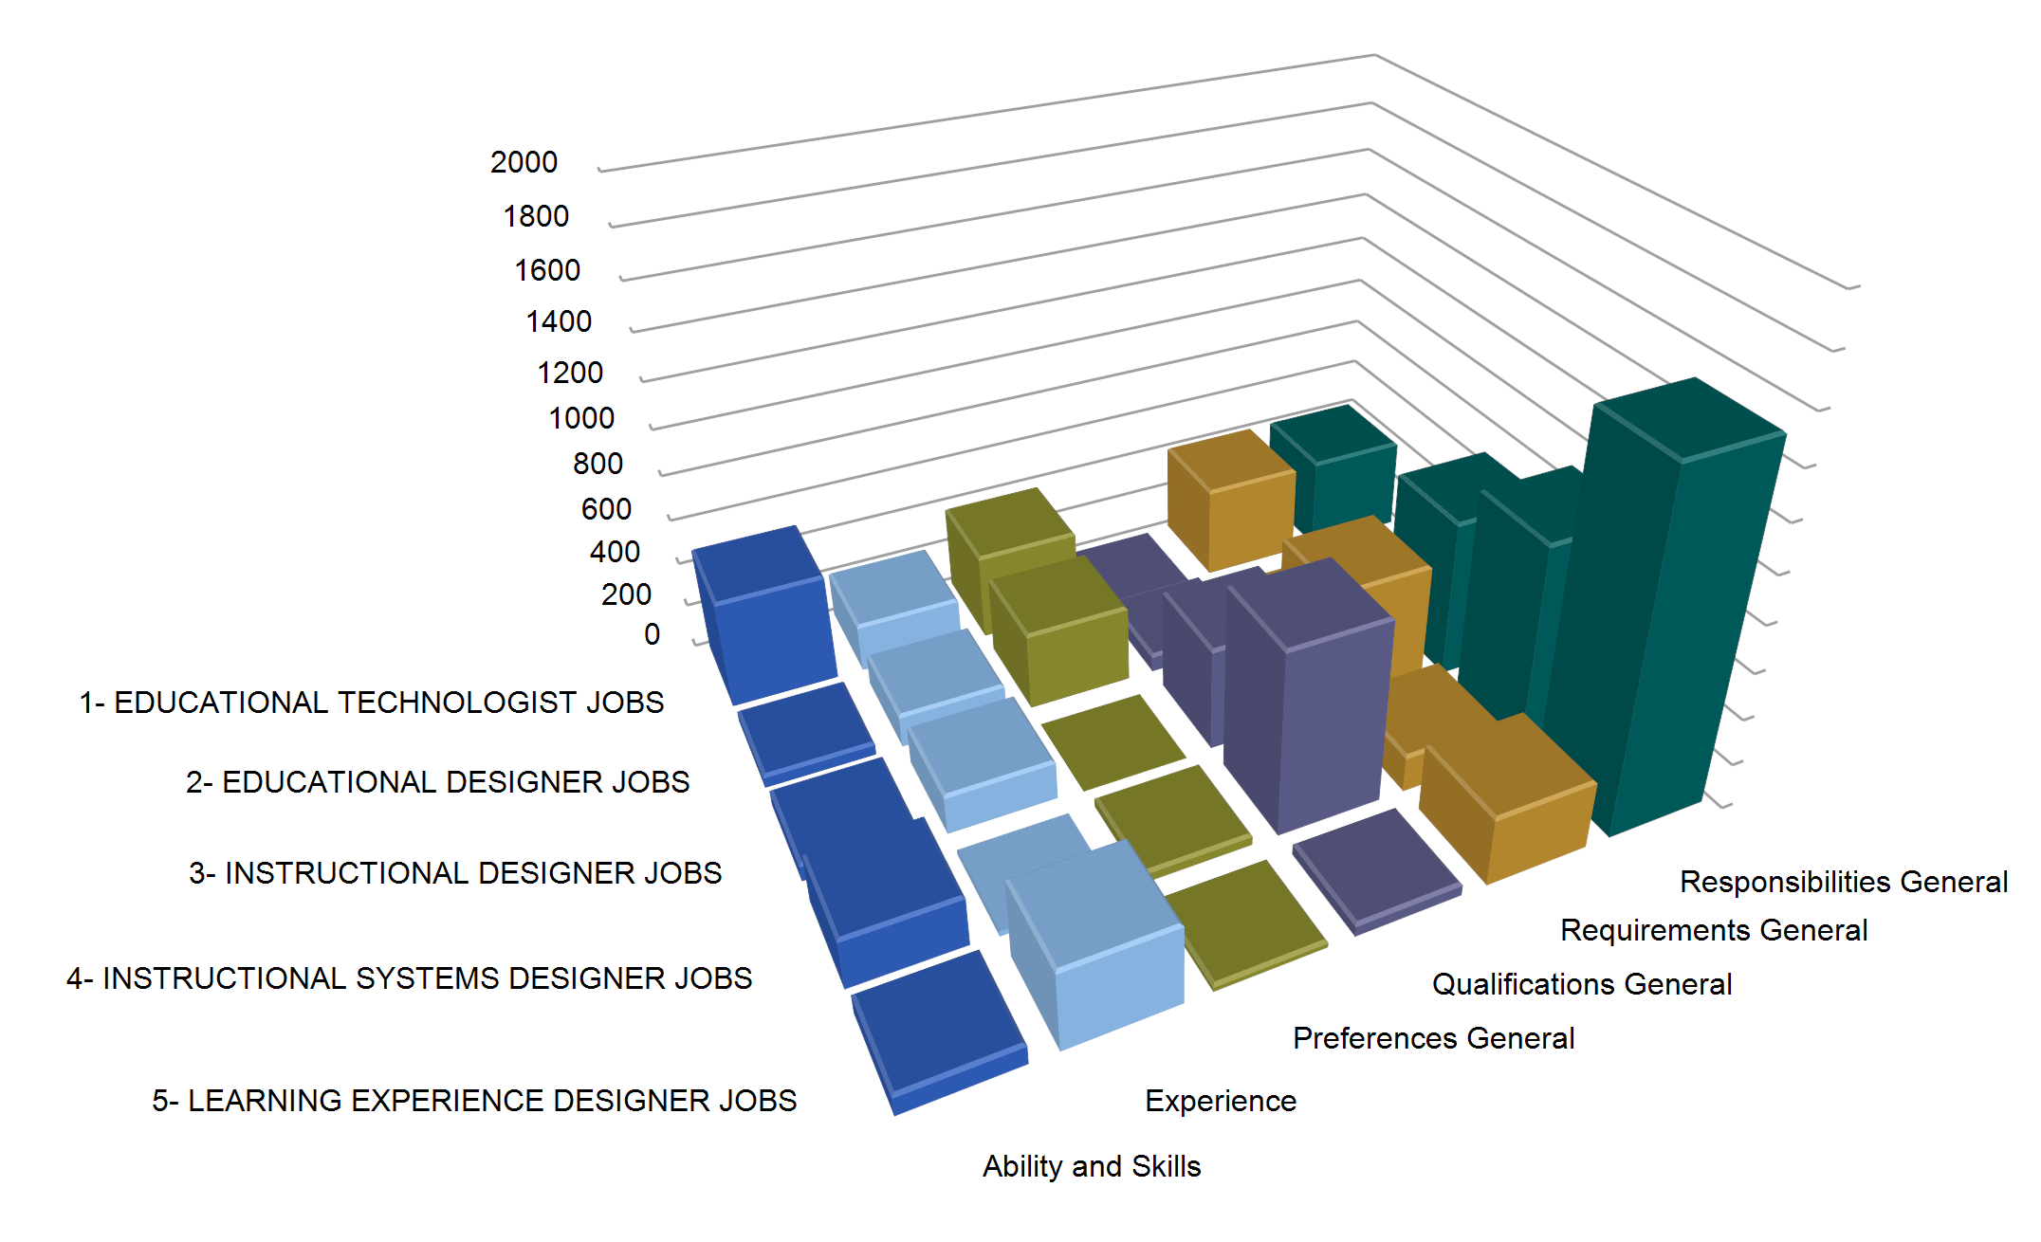
Figure 1. The number of node references by the discipline.

Furthermore, we have examined the dominant, mutual, or negotiated discourse of the job postings for each field. Drawing from Hall's Model, dominant discourse refers to highly emphasized elements expected from the applicants by a specific field. Mutual discourse, on the other hand, deals with the elements that different fields have a consensus on. Finally, negotiated discourse is about the unique elements that only one field indicated in the job post template. (1) Ability and Skills; (2) Experience; (3) Preferences, (4) Qualifications; (5) Requirements; and (6) Responsibilities. The corresponding word clouds also depict mostly repeated words for the associated element.

Ability and Skills
Given the coding relations with job categories in Table 4, Educational Technology jobs have a dominant discourse over the ability and skills concept. In other words, from Hall’s topology of encoding position, Educational Technology in that position is powerful to produce the discourses on the definitions of needed skills and abilities used in the job ads. It mainly defined five different skills and abilities. These are learning skills, reasoning skills, organizational skills, business skills, and language ability. On the other hand, Educational Technology and Instructional Systems Technology positions had a mutual acceptance on the definition of learning skills. In terms of negotiated acceptance, Learning Experience Design emphasizes management skills and Educational Design emphasized desired skills.

Table 4. Coding relations of the job categories and word cloud of ability and skills theme
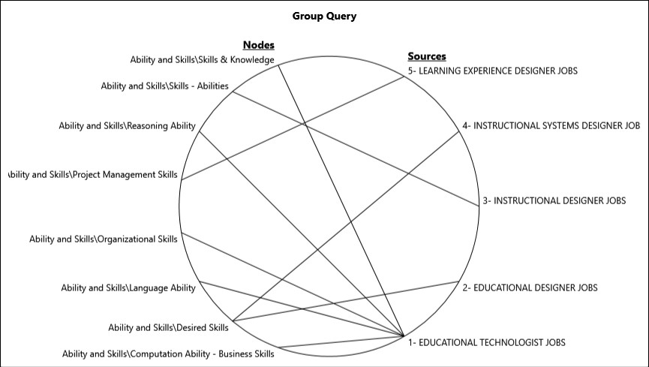 | 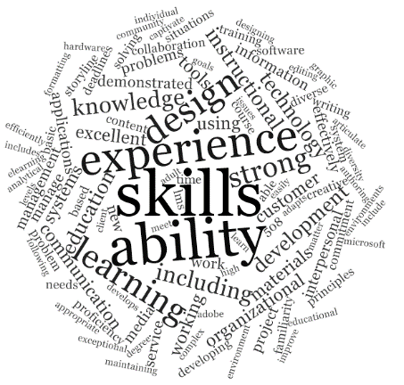

Experience
In the experiences category, Learning Experience Design dominated the discourse on the work experience such as experience with client-facing, in responsive design for multiple platforms, and direct experience with vendors. In addition, learning experience in designing and developing learning materials and innovative curriculum and certification programming are the other concentration points. In a similar manner, Instructional Design has a dominant discourse on three points: (1) the familiarity with specific software such as Captivate, Storyline, and Adobe Creative Suite as well as Internet and e-mail applications and Learning Management Systems Quality Matters rubrics; (2) required experiences experience to design and development of curriculum; and (3) demonstrated experience of adult learning theories and instructional design principles. The findings for Instructional Designer positions, on the other hand, more often had a negotiated acceptance on the number of years in the experience category. Table 5 shows interrelationship graph on the discourse of fields and word cloud of the word frequency for the experience theme.

Table 5. Coding relations of the job categories and word cloud of experience theme
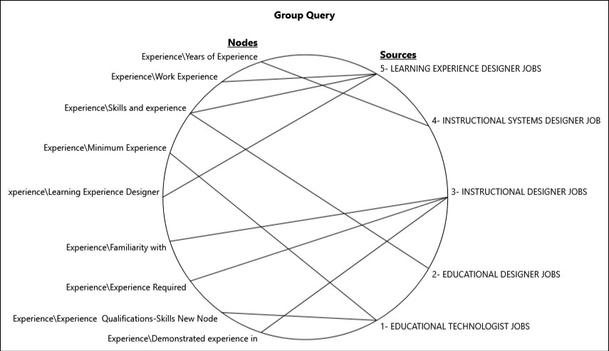

Preferences
In the preferences category, Educational Technology positions were dominated by discourse on the preferred experiences such as Microsoft products, storyline, agile framework, familiarity with flipped learning, visual design, and classroom management. The rest of the jobs had negotiated discourse on the preferred experiences. One of the significant findings in these negotiated categories is about the “What you will do” section of the Educational Design. Although the others deal with past experiences of the applicant, educational design provides in-depth description for the future activities such as designing online learning, developing multimedia learning modules, and serving as an instructional designer. This discourse can be interpreted as the unpredictability of the tasks and the continuously changing demands of the market. Table 6 shows interrelationship graph on the discourse of fields and word cloud of the word frequency for the preferences theme.

Table 6. Coding relations of the job categories and word cloud of preferences theme

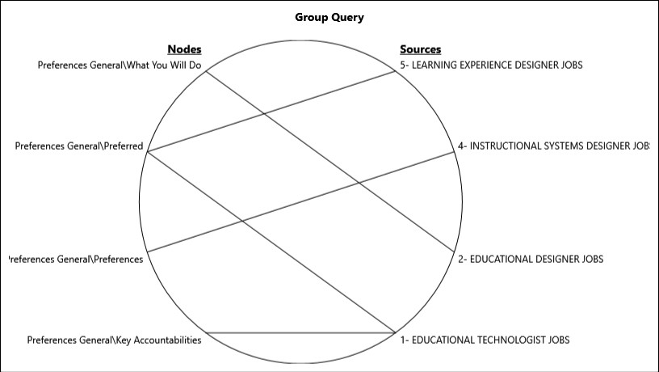

Qualifications
Educational Design, Learning Experience Design, Instructional Systems Design, and Instructional Design positions had a mutual understanding on the qualifications. Degree, certification, higher communication skills, and specific years of experience were some of the examples in this category. Instructional Systems Designer, on the other hand, had a negotiated acceptance on the minimum number of years’ experience. Table 7 shows interrelationship graph on the discourse of fields and word cloud of the word frequency for the qualifications theme.

Table 7. Coding relations of the job categories and word cloud of qualifications theme

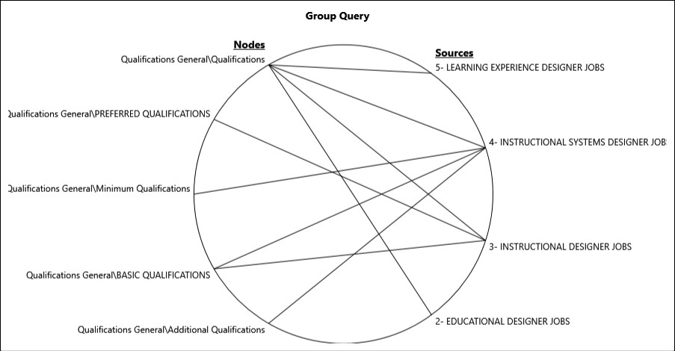

Requirements
Job postings for Educational Technology, Learning Experience Design, Instructional Systems Design, and Instructional Design had a mutual understanding on the general requirements. Examples include having a degree/certification, knowledge of learning theories and instructional design models, strong communication skills, strong organization skills, specific number of years’ experience in the field, and experience with specific software. Instructional Design also has a negotiated requirement on the physical abilities such as constantly performing desk-based computer tasks, rarely writing by hand, and using a telephone. Table 8 presents interrelationship graph on the discourse of fields and word cloud of the word requirements for the requirements theme.

Table 8. Coding relations of the job categories and word cloud of requirements theme

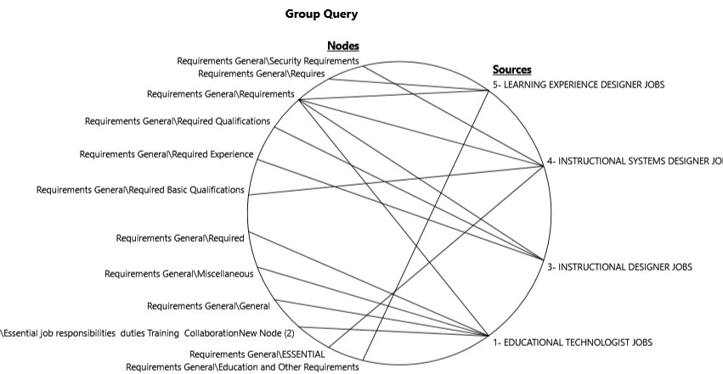

Responsibilities
Learning Experience Design, Instructional Systems Design, and Instructional Design related job announcements had a mutual understanding on the general responsibilities. Examples include the development of training and instruction, conducting evaluation and needs analysis, being familiar with specific software, and supporting learning. Furthermore, Educational Technology positions had a negotiated discourse on the “other duties may be assigned." Table 9 presents interrelationship graph on the discourse of fields and word cloud of the word requirements for the responsibilities theme.

Table 9. Coding relations of the job categories and word cloud of responsibilities theme

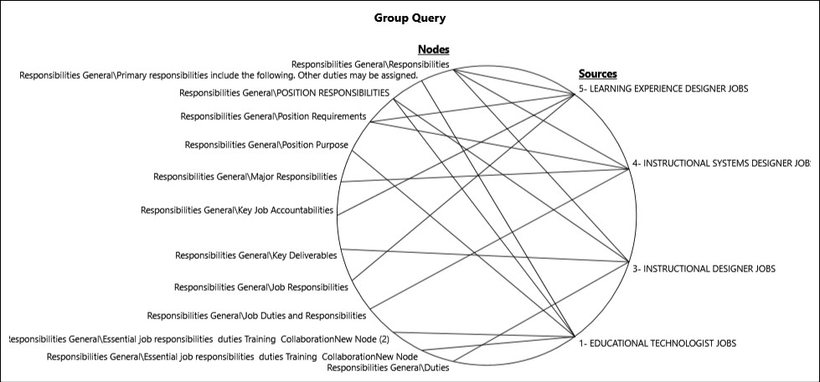 | 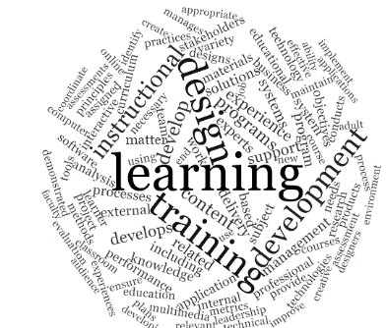

Language-in-use in the Twitter Analysis

In addition to the descriptive analysis explained above, the second part of the analysis was conducted on the language-in-use in the Twitter job posts. We focused on words like apply, looking for, serve and position to depict how they are used and reproduced in the job ads.

As displayed in Table 10, looking-in-use is another important and consistent code that emerged from the language-in-use in the data. It is presented in the second line of the Table 5. Its relations seem that there is again the mutual acceptance about being creative, professional, and innovative. These are explicitly written in the texts. When the aim of its complete usage in the text, the searches done by companies for creative, professional, and designer are implicitly highlighted around it. Our interpretations of looking-in-use became more comprehensive by extending its meaning horizon.

Table 10. Intertextuality and language-in-use relations with the job categories for looking-in-use

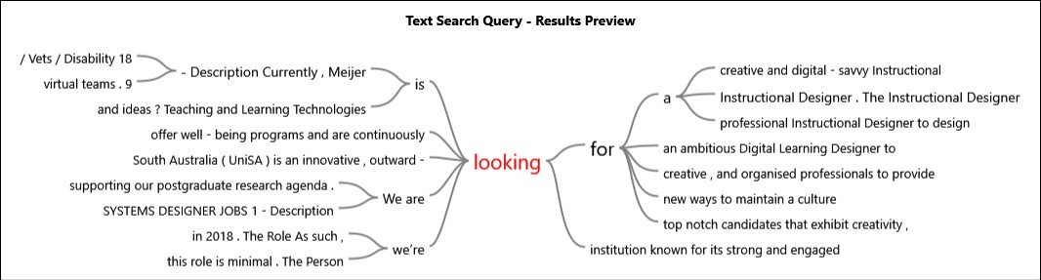

Secondly, table 11 indicates that apply-in-use is the important code to read the data in an intertextual and intersectional way. As it is seen in the first figure of the table, the word of apply is used with the associations of visit, now, to and now. When our synthesis of Hall and Meadows typologies is refined around the concept of apply as the elements by and in which the encoding processes of job ads is culturally produced with the concept of place and position. This indicates that the predicative forces of the apply-in-use culturally produce the discourses about directions for the reader about the place to visit to complete process and positions for which the applicant could work for.

Table 11. Intertextuality and language-in-use relations with the job categories for apply-in-use

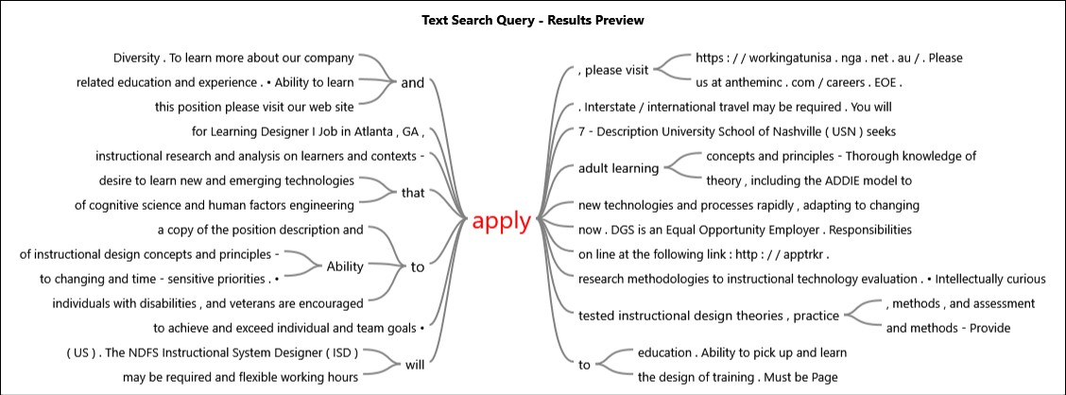

Finally, as presented in table 11, serve-in-use is another semantic code in the data. Third figure from the Table 5 is about sense in our data. Like apply and looking, it also produces the dominant discourse about the instructional designer and designer. It might be claimed that companies releasing the job ads looked for having more from the applications. For example, the expectation about being a leader, coach, primary point, and liaison are the expressions about their expectations. In that sense, these terms serve as a predicative and discursive force. In effect, it seems that as being an element in the language-in-use creates Meadows' interconnections between the expectations of companies and the importance of position. Hall's typology also confirms that the mutual negations about the discourses of the sense-in-use.

Table 12. Intertextuality and language-in-use relations with the job categories for serve-in-use

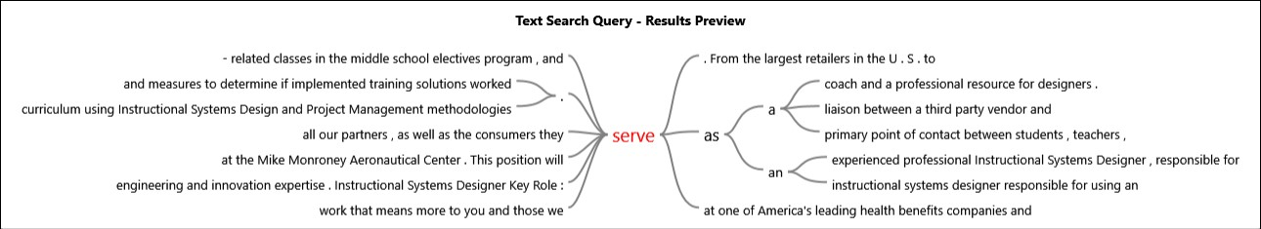

Discussion

Based on the template analysis, we have found six interrelationships within the discourse of targeted fields including the following: (1) Ability and Skills; (2) Experience; (3) Preferences, (4) Qualifications; (5) Requirements; and (6) Responsibilities.
The findings suggest that Educational Technology is dominated by discourse related to the “Ability and Skills” and “Preferences” categories. As indicated in a 2004 AECT definition, Educational Technology is a “study and ethical practice of facilitating learning and improving performance by creating, using, and managing, appropriate technological processes and resources” (AECT, 2004). Thus, it is not surprising to see its dominance in the areas of learning skills, reasoning skills, organizational skills, business skills, and language ability; and preferred experiences such as Microsoft products, Storyline, Agile Framework, familiarity with flipped learning, visual design and classroom management. It is also suggested by the findings that Educational Technology has mutual discourse with Instructional Design; most notably in the areas of “Requirements” such as having a degree/certification, knowledge of learning theories and instructional design models, strong communication skills and strong organization skills; and “Responsibilities” such as the development of training and instruction, conducting evaluation and needs analysis, being familiar with specific software, and supporting learning.
Considering these two findings and Stuart Hall’s (1980) communication model, we can locate the Educational Technology and Instructional Design to the message channels (see Figure 2). Message channel is a medium through which a message is sent or received between people. According to Hall (1980), when selecting a channel, the availability, suitability, and cost of the channel, type of message that is sent or received, and the communication skills of the sender and receivers are considered. These considerations are processed by the disciplines of Instructional Design and Educational Technology in the figure. Both entail the application of strategies and techniques coming from behavioral, cognitive, and constructivist theories to solve the instructional problems and to facilitate and evaluate learning through technology under conditions that are purposive and controlled. In other words, they focus on increasing the efficiency and effectiveness of the tools (i.e., the channel) to carry the message accurately to the learner. The semantic analysis of the language also supports this claim. As explained above, serve-in-use language is the dominant discourse about the instructional designer. The expectations from them are being leader, coach, primary point, or liaison for teaching and learning situations.
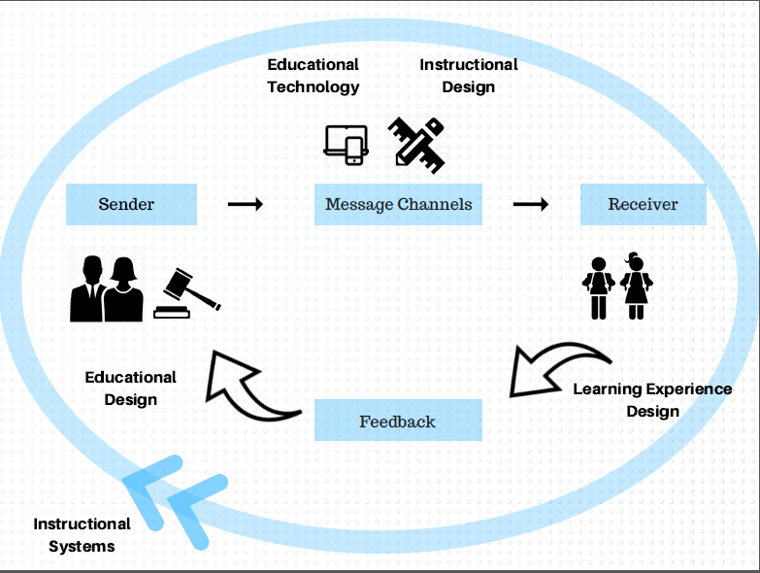
Figure 2. Hall’s Communication Model (Adapted and modified for the current study)

Secondly, as it is presented in Figure 2, the Educational Design discipline was located at the beginning (sender) of the communication model. Educational designers are expected to investigate research methods and apply appropriate learning theory to the design of learning materials and learning events in order to ensure that the desired goals are fulfilled (AECT, 2004). In effect, they plan the educational event or experience to transmit the values, rules, and beliefs. When properly enacted, the ideologies (i.e., the message) of policy makers can benefit the learners (i.e., the society). Ideologies are defined as images, concepts, and premises which provide the frameworks through which we represent, interpret, understand, and 'make sense' of some aspect of social existence (Dines & Humez, 2003, p. 89). The template analysis findings support this claim. It indicates that Educational Design has a negotiated discourse on the preferred experiences. For instance, “What you will do” section of the Educational Design position announcements provide guidelines on the future activities rather than past collection of activities. This discourse can be interpreted as the unpredictability of the tasks and the continuously changing demands of society and the market.

The third component of the model is the receiver who is an individual or a group of people intended to receive, interpret, or decode the message. For this reason, the “Learning Experience Design” discipline was located in the receiver portion of the model. The definition of the term indicates that Learning Experience Design is the practical side of education. The specific teaching-learning processes that occur in a lesson, a unit of learning, or a course is the major concern of this field (Walsh, 2017). In other words, learning designers craft the instruction specifically based on the needs of the learners. They accomplish these goals by considering the existing standards as defined by educational designers. Learning designers also take into account the tools studied as well as methods that are proven effective by instructional designers and educational technologists. Considering the template analysis, it is seen that Learning Experience Design has a dominant discourse on the work experience such as experience with client-facing, in responsive design for multiple platforms, and in direct experience with vendors. Also deemed important is experience in designing and developing learning materials and innovative curriculum and certification programming.

Final component of the model is feedback. Feedback is highly essential as a signal that the receiver has understood the main message (Hall, 1980). “Instructional Systems” discipline is ideally situated at this point because of its systematic nature. People working in these professions make practical and theoretical arrangement of resources and procedures based on feedback coming from the learner, environment, sender, and/or channel to promote learning. The fact that Instructional Systems Design has a mutual discourse with other fields about Requirements and Qualifications, support this claim.

Study Significance and Future Research
Systems thinking is essential in dealing with the complexities of the twenty-first century (Meadows, 2008; Senge, 1990). As these disciplines continue to grow and evolve, the boundaries between them become blurred and open to misinterpretation (Gibbons, 1997). Consequently, a better understanding of the interrelations among the disciplines can serve as a guide for both employers and employees to make more accurate decisions such as those related to hiring people or applying for open positions in field of educational technology.
The current study is an initial attempt to quantify and correlate existing interactions in five technology related disciplines by using social network analysis from Twitter posts. It provides one glimpse into the complex responsibilities of those employed in the field of instructional design and technology (Intentional Futures, 2016) as well as associated fields. Future research might extend this approach to other social media tools (e.g., Facebook, WordPress, and LinkedIn) as well as to those disciplines which also suffer from a high growth-related identity crisis. Next steps might also include ethnographic studies of those employed in this field, including the documentation of the changing demands over several years or over a decade or more. Researchers might also more specifically explore the varying skills and competencies that different types of institutions, organizations, and companies might be demanding. In particular, a better grasp of where learning experience designers, instructional designers, educational designers, instructional technologists, instructional systems designers, and others in related fields might find employment—especially in high growth industries or educational sectors. Such a research report should have enormous societal benefits.
Without a doubt, the avenues for learning and instruction continue to proliferate (Authors, 2009, 2016). As new delivery mechanisms for learning unfold across all sectors of education and training, those designing, delivering, and evaluating and assessing such learning will be increasingly in demand. The job roles and responsibilities will continue to expand and offer employment possibilities for those who today are vaguely aware of these fields. Over time, fresh models and frameworks will be needed to better understand the job requirements and expectations. At the same time, innovations in curriculum and credentialing programs in these fields will emerge to assist the tens of thousands of people who will need continual forms of preparedness and training to acquire, maintain, and update the skills needed for success as learning experience designers, instructional designers, educational designers, instructional technologists, instructional systems designers and beyond.

References
Adams Becker, S., Freeman, A., Giesinger Hall, C., Cummins, M., & Yuhnke, B. (2016). NMC/CoSN Horizon Report: 2016 K-12 Edition. Austin, Texas: The New Media Consortium. Retrieved from http://cdn.nmc.org/media/2016-nmc-cosn-horizon-report-k12-EN.pdf
Allen, E., & Seaman, J. (2013). Grade change: Tracking online education in the United States, 2013. The Sloan Consortium, 2013 Survey of Online Learning Report. Retrieved from http://www.onlinelearningsurvey.com/reports/gradechange.pdf
Allen, E., & Seaman, J. with Poulin, R. & Taylor Straut, T. (2016, February). Online report card: Tracking online education in the United States. Babson Survey Research Group. Full Report: Retrieved from http://onlinelearningsurvey.com/reports/onlinereportcard.pdf
Association for Educational Communications and Technology (AECT). (2004). The definition of educational technology. Washington, DC: Author.
Aronson, D. 1998. Overview of systems thinking. Retrieved from http://www.thinking.net/Systems_Thinking/OverviewSTarticle.pdf
Aziz, D. M. (2013). What's in a name? A comparison of instructional systems design, organization development, and human performance technology/improvement and their contributions to performance improvement. Performance Improvement, (6), 28.
Beattie, S. (1999). What is educational technology? BiblioTech. 1(1). Formerly available online http://www2.augustana.edu/library/Newsletter1/index.htm
Berrett, D. (2016, February 29). Instructional Design: Demand grows for a new breed of academic, The Chronicle of Higher Education. Retrieved from http://chronicle.com/article/Instructional-Design/235425
Brown, J. S., & Adler, R. P. (2008, January/February). Minds on fire: Open education, the long tail, and learning 2.0. EDUCAUSE Review, 43(1), 16-32. Retrieved from https://net.educause.edu/ir/library/pdf/ERM0811.pdf
Chang, R. (2016, July 28). Learning management system market expected to grow $10.5 billion in next 5 years. Campus Technology. Retrieved from https://campustechnology.com/articles/2016/07/28/learning-management-system-market-expected-to-grow-10.5-billion-in-next-5-years.aspx
Chen, B., & Bryer, T. (2012, January). Investigating instructional strategies for using social media in formal and informal learning. The International Review of Research on Open and Distance Learning, 13(1), 87-104. Retrieved from http://www.irrodl.org/index.php/irrodl/article/view/1027/2073
CNN Money (2012). Best jobs in America: 38. Instructional designer. Retrieved from http://money.cnn.com/pf/best-jobs/2012/snapshots/38.html
Corbeil, J. R., & Corbeil, M. E. (2013). What do educational technologists do? The discipline as defined by educational technology practitioners. Issues in Information Systems, 14(2), 336-345. Retrieved from http://iacis.org/iis/2013/301_iis_2013_336-345.pdf
Dines, G., & Humez, J. M. (2003). Gender, race, and class in media: A text-reader. Thousand Oaks, CA: Sage.
Ely, D. (2008). Frameworks of educational technology. British Journal of Educational Technology, 39(2), 244–250.
Fischer, L., Hilton, J., Robinson, J., & Wiley, D. (2015, December). A multi-institutional study of the impact of open textbook adoption on the learning outcomes of post-secondary students, Journal of Computing in Higher Education, 27(3), 159-172. Available:
http://link.springer.com/article/10.1007/s12528-015-9101-x/fulltext.html
Gagné, R., & Briggs, L. (1974). Principles of instructional design. New York: Holt, Rinehart and Winston.
Gibbons, M. (1997). What kind of university? City Campus: ACU.
Hall, S. (1980). Encoding/decoding. In S. Hall, D. Hobson, A. Lowe, and P. Willis (Eds), Culture, media, language. London: Hutchinson/CCCS. Retrieved from https://spstudentenhancement.files.wordpress.com/2015/03/stuart-hall-1980.pdf
Hardman, S. (2016; December 26). Glimpse into the future of learning. New Learning Times, https://newlearningtimes.com/cms/article/4007/apps-of-the-future
Hlynka, D., & Jacobsen, M. (2009). What is educational technology, anyway? A commentary on the new AECT definition of the field. Canadian Journal of Learning and Technology/La revue canadienne de l’apprentissage et de la technologie, 35(2).
Intentional Futures (2016, April). Instructional design in higher education: A report on the role, workflow, and experience of instructional designers. Seattle, WA: Gates Foundation. Retrieved from http://intentionalfutures.com/reports/instructional_design/files/Instructional%20Design%20in%20Higher%20Education%20Report.pdf
Lincoln, Y. S., & Guba, E. G. (1985). Naturalistic inquiry. Newbury Park, CA: Sage
Publications.
Johnson, L., Adams Becker, S., Cummins, M., Estrada, V., Freeman, A., & Hall, C. (2016). NMC Horizon Report: 2016 Higher Education Edition. Austin, Texas: The New Media Consortium. Retrieved from http://cdn.nmc.org/media/2016-nmc-horizon-report-he-EN.pdf
Kim, J. (2018, March 8). Career Opportunities at the Intersection of Learning and Technology. [Blog Post]. Inside Higher Ed. Retrieved from https://www.insidehighered.com/blogs/technology-and-learning/career-opportunities-intersection-learning-and-technology
Klein, J. T. (1990). Interdisciplinarity. Detroit: Wayne State University Press.
Lee, J. (2016). Social network analysis of peer relationships and online interactions in a blended class using blogs. The Internet and Higher Education, 28(1), 35-44. doi:10.1016/j.iheduc.2015.09.001; Available:http://www.sciencedirect.com/science/article/pii/S1096751615000597
Meadows, D. H. (2008). Thinking in systems: A primer. White River Junction, VT: Chelsea Green Publishing.
Merriam, S. B. (2009). Qualitative research: A guide to design and implementation. San
Francisco, CA: Jossey Bass.
Owston, R. (2017). Empowering learners through blended learning. International Journal on E-Learning, 17(1), 65-83. Retrieved from http://www.yorku.ca/rowston/IJEL2017.pdf
Peppler, K. (2013). New opportunities for interest-driven arts learning in a digital age (Deliverable to the Wallace Foundation). Bloomington, Indiana: Indiana University. Retrieved from http://kpeppler.com/Docs/2013_Peppler_New-Opportunities-for-Interest-Driven-Art.pdf
Ravipati, S. (2016, September 21). Udacity unveils nanodegree program for self-driving car engineers. Campus Technology. Retrieved from https://campustechnology.com/articles/2016/09/21/udacity-unveils-nanodegree-program-for-selfdriving-car-engineers.aspx
Richey, R.C., Klein, J.D., & Tracey, M.W. (2011). The instructional design knowledge base: Theory, research and practice. New York, NY: Routledge.
Riter, P. (2016, June 7). The quest for great instructional designers, Inside Higher Ed. Retrieved from https://www.insidehighered.com/advice/2016/06/07/troublesome-shortage-instructional-designers-essay
Robbins, G. (2016; December 15). How robots will change the American workforce. The San Diego Union-Tribune. Retrieved from http://www.sandiegouniontribune.com/news/science/sd-me-robots-jobs-20161213-story.html
Scanlon, E., Sharples, M., Fenton-O'Creevy, M., Fleck, J., Cooban, C., Ferguson, R., Cross, S., & Waterhouse, P. (2013). Beyond prototypes: Enabling innovation in technology-enhanced learning. University of London, Technology-Enhanced Learning Research Programme, London, UK. Retrieved from http://tel.ioe.ac.uk/wp-content/uploads/2013/11/BeyondPrototypes.pdf
Senge, P. (1990). The fifth discipline, the art and practice of the learning organization. New York, NY: Doubleday/Currency.
Sharples, M., Adams, A., Ferguson, R., Gaved, M., McAndrew, P., Rienties, B., Weller, M., & Whitelock, D. (2014). Innovating pedagogy 2016: Open University innovation report 5. Milton Keynes: The Open University. Retrieved from http://proxima.iet.open.ac.uk/public/innovating_pedagogy_2016.pdf
Stansbury, M. (2017, June 26). Stunning market data predicts the future of online learning. eCampus News. Retrieved from https://www.ecampusnews.com/featured/featured-on-ecampus-news/market-future-online-learning/
Sterman, J. D. (2003). System dynamics: Systems thinking and modeling for a complex world. In ESD International Symposium.
Tang, Y. (2013). Distance Education Librarians in the United States: A Study of Job Announcements. The Journal of Academic Librarianship, 39(6), 500-505. doi:10.1016/j.acalib.2013.08.012
Veletsianos, G., & Navarrete, C. C. (2012, January). Online social networks as formal learning environments: Learner experiences and activities. The International Review of Research on Open and Distance Learning, 13(1). Retrieved from http://www.irrodl.org/index.php/irrodl/article/view/1078/2077
Walsh, K. (2017, January 17). 8 resources exploring learning experience design (LX Design). EmergingEdTech. Retrieved from http://www.emergingedtech.com/2017/01/8-resources-exploring-learning-experience-lx-design/
Yin, R. K. (2011). Qualitative research from start to finish. New York, NY: Guilford Press.

